Supplementary Materials

1. **Master Table – NAME????**
   1. Table 1 – Name of table

|  |  |  |  |
| --- | --- | --- | --- |
| Lipid(s) | Current Classification | Suggested Classification | Details |
| LMFA01010053 | Fatty Acyls [FA] >  Fatty Acids and Conjugates [FA01] >  Straight chain fatty acids [FA0101] | Fatty Acyls [FA] >  Fatty Acids and Conjugates [FA01] > Branched fatty acids [FA0102] | 2.1 |
| LMFA01020363, LMFA01020364 | Fatty Acyls [FA] >  Fatty Acids and Conjugates [FA01] >  Branched fatty acids [FA0102] | Fatty Acyls [FA] >  Fatty Acids and Conjugates [FA01] >  Unsaturated fatty acids [FA0103] | 2.2 |
| LMFA01030188, LMFA01030189, LMFA01030191 | Fatty Acyls [FA] >  Fatty Acids and Conjugates [FA01] >  Unsaturated fatty acids [FA0103] | Fatty Acyls [FA] >  Fatty Acids and Conjugates [FA01] >  Carbocyclic fatty acids [FA0114] | 2.3 |
| LMFA01020274, LMFA01020276 | Fatty Acyls [FA] >  Fatty Acids and Conjugates [FA01] >  Branched fatty acids [FA0102] | Fatty Acyls [FA] >  Fatty Acids and Conjugates [FA01] >  Oxo fatty acids [FA0106] | 2.4 |
| LMFA01030579 | Fatty Acyls [FA] >  Fatty Acids and Conjugates [FA01] >  Unsaturated fatty acids [FA0103] | Fatty Acyls [FA] >  Fatty Acids and Conjugates [FA01] >  Oxo fatty acids [FA0106] | 2.5 |
| LMFA01030675, LMFA01030676 | Fatty Acyls [FA] >  Fatty Acids and Conjugates [FA01] >  Unsaturated fatty acids [FA0103] | Fatty Acyls [FA] >  Fatty Acids and Conjugates [FA01] >  Halogenated fatty acids [FA0109] | 2.6 |
| LMFA01030714 | Fatty Acyls [FA] >  Fatty Acids and Conjugates [FA01] >  Unsaturated fatty acids [FA0103] | Fatty Acyls [FA] >  Fatty Acids and Conjugates [FA01] >  Hydroxy fatty acids [FA0105] | 2.7 |
| LMFA01030717 | Fatty Acyls [FA] >  Fatty Acids and Conjugates [FA01] >  Unsaturated fatty acids [FA0103] | Fatty Acyls [FA] >  Eicosanoids [FA03] > Hydroxy/hydroperoxyeicosapentae-noic acids [FA0307] | 2.8 |
| LMFA01030719 | Fatty Acyls [FA] >  Fatty Acids and Conjugates [FA01] > Unsaturated fatty acids [FA0103] | Fatty Acyls [FA] >  Eicosanoids [FA03] > Hydroxy/hydroperoxyeicosatetrae-noic acids [FA0306] | 2.9 |
| LMFA01030750, LMFA01030790, LMFA01030792, LMFA01030796, LMFA01030797, LMFA01030798, LMFA01030799, LMFA01030893, LMFA01030895, LMFA01030905 | Fatty Acyls [FA] >  Fatty Acids and Conjugates [FA01] > Unsaturated fatty acids [FA0103]  What about this space???? | Fatty Acyls [FA] >  Fatty Acids and Conjugates [FA01] >  Branched fatty acids [FA0102] | 2.10 |
| LMGP01030016 | Glycerophospholipids [GP] > Glycerophosphocholines [GP01] >  1-(1Z-alkenyl),2-acylglycerophosphocholines [GP0103] | Glycerophospholipids [GP] > Glycerophosphoethanolamines [GP02] > Diacylglycerophosphoethanolamines [GP0201] | 2.11 |
| LMGP04040006 | Glycerophospholipids [GP] > Glycerophosphoglycerols [GP04] > Dialkylglycerophosphoglycerols [GP0404] | Glycerophospholipids [GP] > Glycerophosphoglycerols [GP04] >  1-acyl,2-alkylglycero-phosphoglycerols [GP0411] | 2.12 |
| LMSP0505DO01 | Sphingolipids [SP] >  Neutral glycosphingolipids [SP05] >  Galβ1-4GlcNAcβ1-3Galβ1-4Glc- (Neolacto series) [SP0505] | Sphingolipids [SP] >  Neutral glycosphingolipids [SP05] >  GalNAcβ1-4Galβ1-4Glc- (Ganglio series) [SP0503] | 2.13 |
| LMSP0505DP01-LMSP0505DP08, LMSP0505DQ01-LMSP0505DQ08, LMSP0505DR01-LMSP0505DR08, LMSP0505DS01-LMSP0505DS08 | Sphingolipids [SP] >  Neutral glycosphingolipids [SP05] >  Galβ1-4GlcNAcβ1-3Galβ1-4Glc- (Neolacto series) [SP0505] | Sphingolipids [SP] >  Neutral glycosphingolipids [SP05] >  GalNAcβ1-4Galβ1-4Glc- (Ganglio series) [SP0503] | 2.14 |
| LMSP0505DA01-LMSP0505DA08, LMSP0505DB01-LMSP0505DB08, LMSP0505DJ01-LMSP0505DJ08, LMSP0505DK01-LMSP0505DK08, LMSP0505DL01-LMSP0505DL08 | Sphingolipids [SP] >  Neutral glycosphingolipids [SP05] >  Galβ1-4GlcNAcβ1-3Galβ1-4Glc- (Neolacto series) [SP0505] | Sphingolipids [SP] >  Neutral glycosphingolipids [SP05] >  GalNAcβ1-3Galα1-3Galβ1-4Glc- (Isoglobo series) [SP0506] | 2.15 |

Table 1 caption blah blah blah blah……..

1. **Ontology Reasoning**

2.1

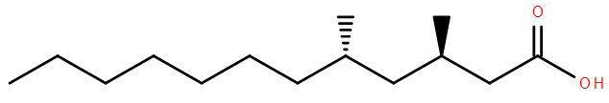

Lipid(s): LMFA01010053

Current classification: Fatty Acyls [FA] > Fatty Acids and Conjugates [FA01] > Straight chain fatty acids [FA0101]

Suggested classification: Fatty Acyls [FA] > Fatty Acids and Conjugates [FA01] > Branched fatty acids [FA0102]

Discussion: This lipid exhibits two branching events characteristic of lipids in the “Branched fatty acids” subclass.

|  |  |
| --- | --- |
| Representative lipids from current subclass: | Representative lipids from suggested subclass: |
| LMFA01010001 | LMFA01020001 |
|  |  |
| LMFA01010002 | LMFA01020002 |
|  |  |
| LMFA01010003 | LMFA01020003 |
|  |  |
| LMFA01010004 | LMFA01020004 |
|  |  |

2.2



Lipid(s): LMFA01020363, LMFA01020364

Current classification: Fatty Acyls [FA] > Fatty Acids and Conjugates [FA01] > Branched fatty acids [FA0102]

Suggested classification: Fatty Acyls [FA] > Fatty Acids and Conjugates [FA01] > Unsaturated fatty acids [FA0103]

Discussion: These lipids have unsaturated bonds characteristic of lipids in the “Unsaturated fatty acids” subclass, but do not exhibit branching.

|  |  |
| --- | --- |
| Representative lipids from current subclass: | Representative lipids from suggested subclass: |
| LMFA01020001 | LMFA01030001 |
|  |  |
| LMFA01020002 | LMFA01030002 |
|  |  |
| LMFA01020003 | LMFA01030004 |
|  |  |
| LMFA01020004 | LMFA01030005 |
|  |  |

2.3

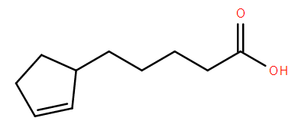

Lipid(s): LMFA01030188, LMFA01030189, LMFA01030191

Current classification: Fatty Acyls [FA] > Fatty Acids and Conjugates [FA01] > Unsaturated fatty acids [FA0103]

Suggested classification: Fatty Acyls [FA] > Fatty Acids and Conjugates [FA01] > Carbocyclic fatty acids [FA0114]

Discussion: These lipids have only have unsaturated bonds in a carbocyclic ring characteristic of some lipids in the “Carbocyclic fatty acids” subclass.

|  |  |
| --- | --- |
| Representative lipids from current subclass: | Representative lipids from suggested subclass: |
| LMFA01030001 | LMFA01140025 |
|  |  |
| LMFA01030002 | LMFA01140028 |
|  |  |
| LMFA01030004 | LMFA01140018 |
|  |  |
| LMFA01030005 | LMFA01140023 |
|  |  |

2.4

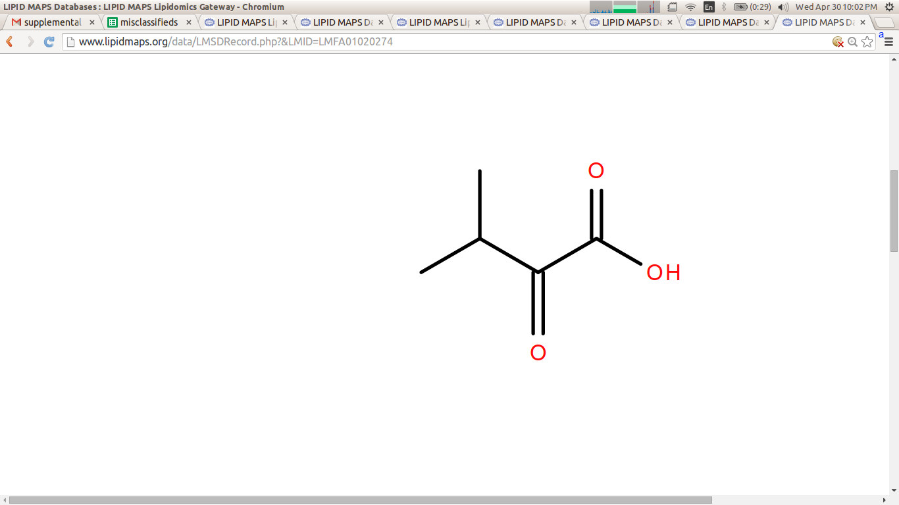

Lipid(s): LMFA01020274, LMFA01020276

Current classification: Fatty Acyls [FA] > Fatty Acids and Conjugates [FA01] > Branched fatty acids [FA0102]

Suggested classification: Fatty Acyls [FA] > Fatty Acids and Conjugates [FA01] > Oxo fatty acids [FA0106]

Discussion: These lipids exhibit an additional carbonyl group characteristic of lipids in the “Oxo fatty acids” subclass.

|  |  |
| --- | --- |
| Representative lipids from current subclass: | Representative lipids from suggested subclass: |
| LMFA01020001 | LMFA01060002 |
|  |  |
| LMFA01020002 | LMFA01060111 |
|  |  |
| LMFA01020003 | LMFA01060157 |
|  |  |
| LMFA01020004 | LMFA01060178 |
|  |  |

2.5

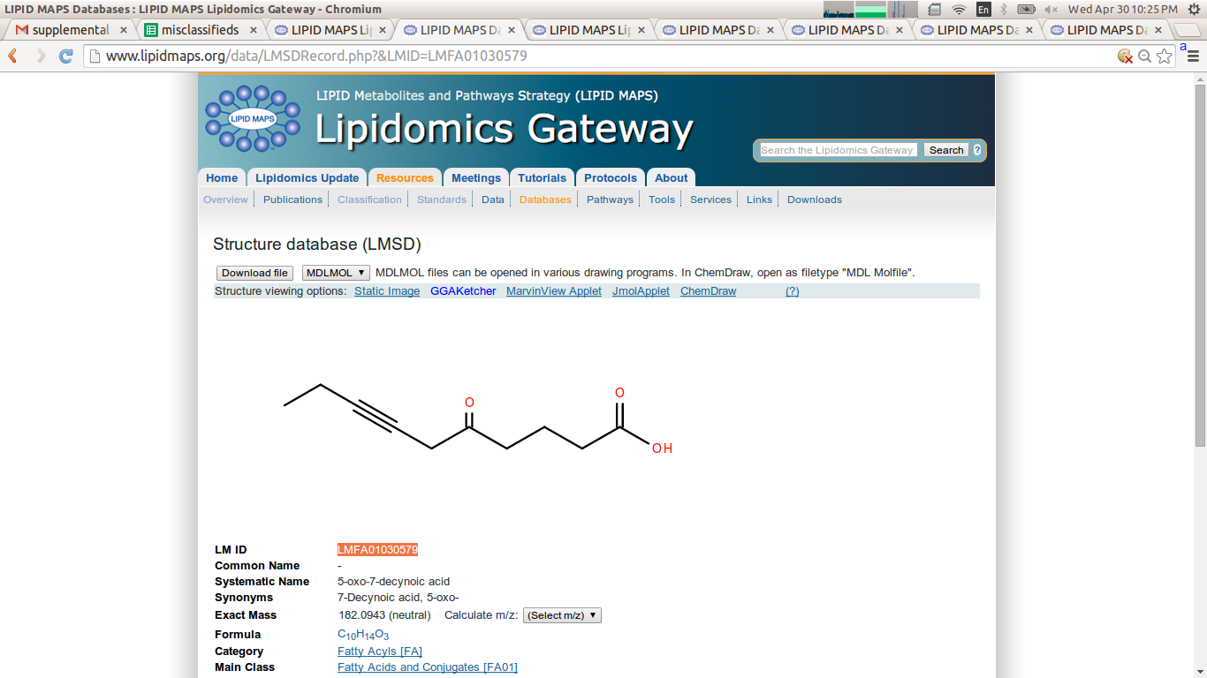

Lipid(s): LMFA01030579

Current classification: Fatty Acyls [FA] > Fatty Acids and Conjugates [FA01] > Unsaturated fatty acids [FA0103]

Suggested classification: Fatty Acyls [FA] > Fatty Acids and Conjugates [FA01] > Oxo fatty acids [FA0106]

Discussion: This lipid exhibits an additional carbonyl group characteristic of lipids in the “Oxo fatty acids” subclass.

|  |  |
| --- | --- |
| Representative lipids from current subclass: | Representative lipids from suggested subclass: |
| LMFA01030006 | LMFA01060148 |
|  |  |
| LMFA01030023 | LMFA01060111 |
|  |  |
| LMFA01030043 | LMFA01060093 |
|  |  |
| LMFA01030048 | LMFA01060095 |
|  |  |

2.6

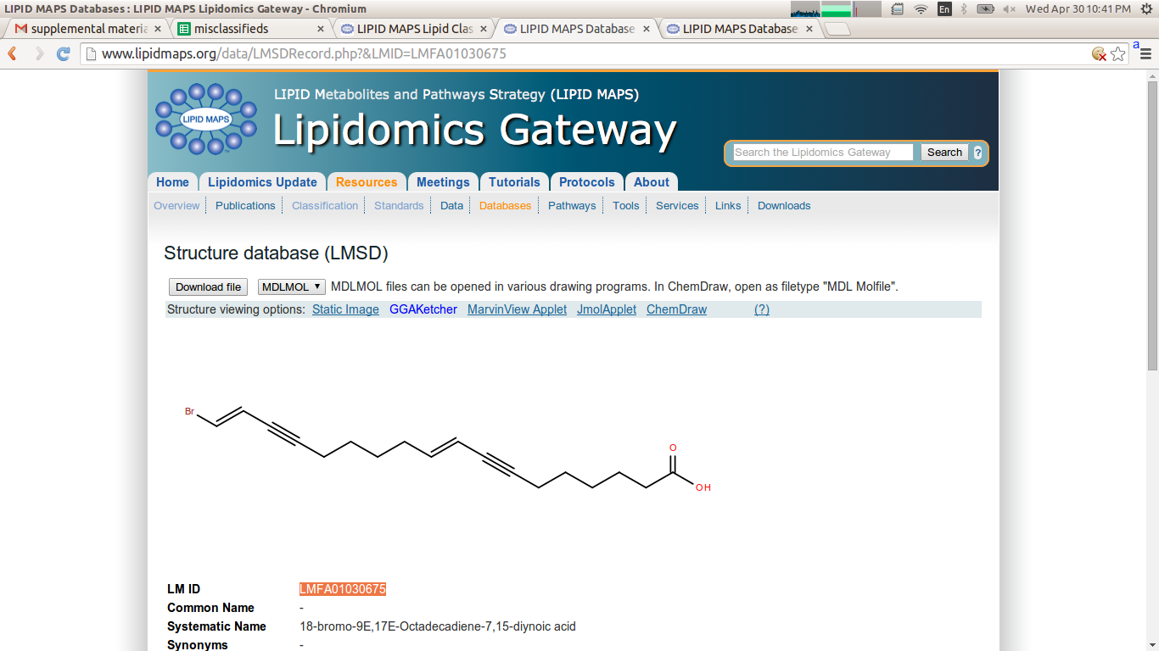

Lipid(s): LMFA01030675, LMFA01030676

Current classification: Fatty Acyls [FA] > Fatty Acids and Conjugates [FA01] > Unsaturated fatty acids [FA0103]

Suggested classification: Fatty Acyls [FA] > Fatty Acids and Conjugates [FA01] > Halogenated fatty acids [FA0109]

Discussion: These lipids are halogenated which is a characteristic of lipids in the “Halogenated fatty acids” subclass.

|  |  |
| --- | --- |
| Representative lipids from current subclass: | Representative lipids from suggested subclass: |
| LMFA01030006 | LMFA01090031 |
|  |  |
| LMFA01030023 | LMFA01090073 |
|  |  |
| LMFA01030043 | LMFA01090088 |
|  |  |
| LMFA01030048 | LMFA01090100 |
|  |  |

2.7

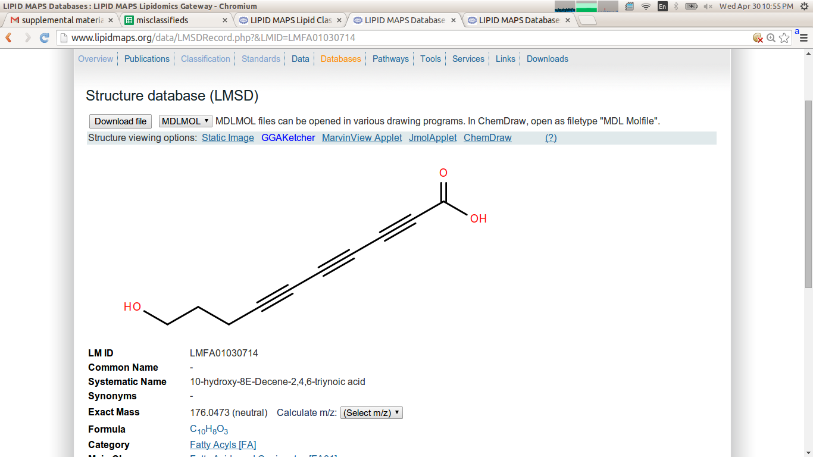

Lipid(s): LMFA01030714

Current classification: Fatty Acyls [FA] > Fatty Acids and Conjugates [FA01] > Unsaturated fatty acids [FA0103]

Suggested classification: Fatty Acyls [FA] > Fatty Acids and Conjugates [FA01] > Hydroxy fatty acids [FA0105]

Discussion: This lipid has a hydroxy group characteristic of lipids in the “Hydroxy fatty acids” subclass.

|  |  |
| --- | --- |
| Representative lipids from current subclass: | Representative lipids from suggested subclass: |
| LMFA01030006 | LMFA01050232 |
|  |  |
| LMFA01030023 | LMFA01050258 |
|  |  |
| LMFA01030043 | LMFA01050272 |
|  |  |
| LMFA01030048 | LMFA01050324 |
|  |  |

2.8

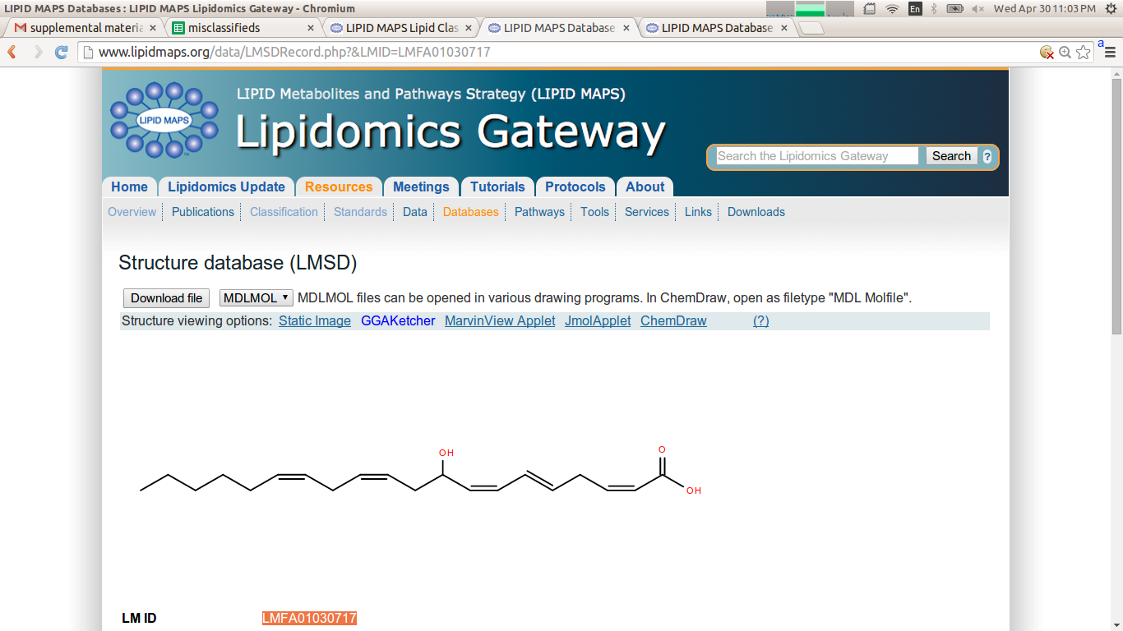

Lipid(s): LMFA01030717

Current classification: Fatty Acyls [FA] > Fatty Acids and Conjugates [FA01] > Unsaturated fatty acids [FA0103]

Suggested classification: Fatty Acyls [FA] > Eicosanoids [FA03] > Hydroxy/hydroperoxyeicosapentaenoic acids [FA0307]

Discussion: This lipid has a hydroxy group as well as five double bonds and 20 carbons, all characteristics of lipids in the “Hydroxy/hydroperoxyeicosatetraenoic acids” subclass.

|  |  |
| --- | --- |
| Representative lipids from current subclass: | Representative lipids from suggested subclass: |
| LMFA01030006 | LMFA03070031 |
|  |  |
| LMFA01030023 | LMFA03070028 |
|  |  |
| LMFA01030043 | LMFA03070041 |
|  |  |
| LMFA01030048 | LMFA03070049 |
|  |  |

2.9

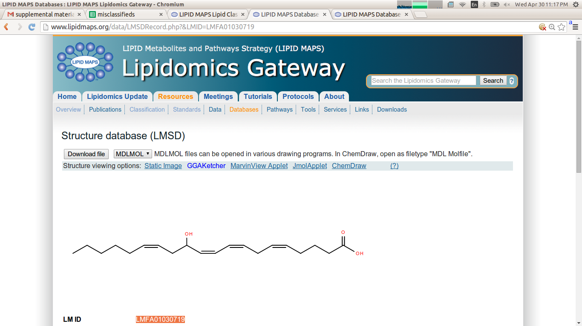

Lipid(s): LMFA01030719

Current classification: Fatty Acyls [FA] > Fatty Acids and Conjugates [FA01] > Unsaturated fatty acids [FA0103]

Suggested classification: Fatty Acyls [FA] > Eicosanoids [FA03] > Hydroxy/hydroperoxyeicosatetraenoic acids [FA0306]

Discussion: This lipid has a hydroxy group as well as four double bonds and 20 carbons, all characteristics of lipids in the “Hydroxy/hydroperoxyeicosatetraenoic acids” subclass.

|  |  |
| --- | --- |
| Representative lipids from current subclass: | Representative lipids from suggested subclass: |
| LMFA01030006 | LMFA03060030 |
|  |  |
| LMFA01030023 | LMFA03060012 |
|  |  |
| LMFA01030043 | LMFA03060018 |
|  |  |
| LMFA01030048 | LMFA03060044 |
|  |  |

2.10

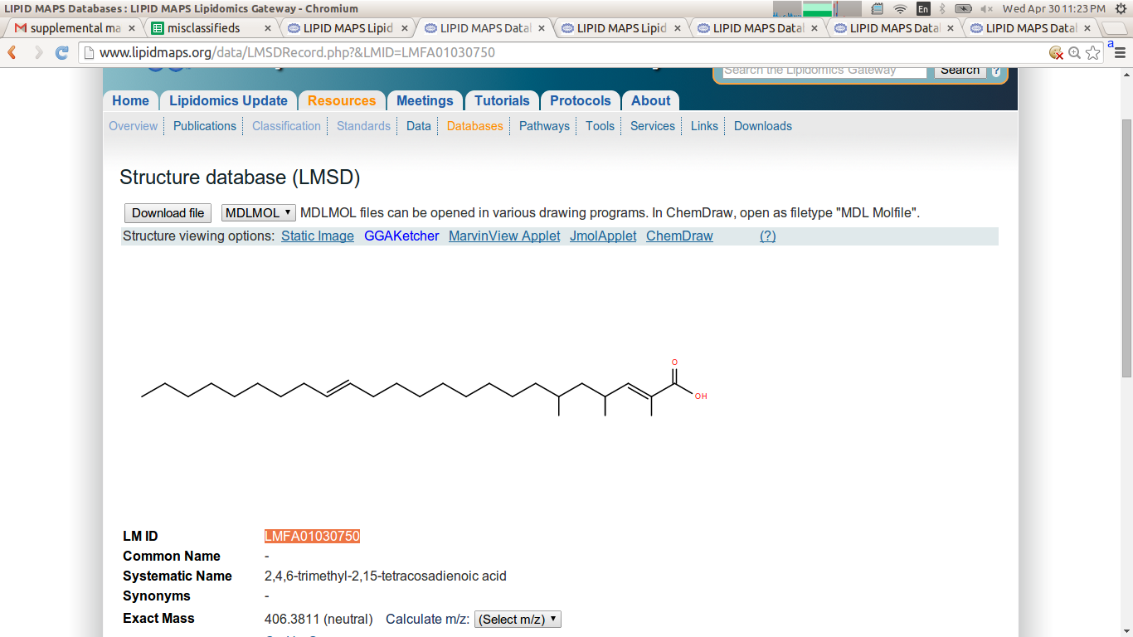

Lipid(s): LMFA01030750, LMFA01030790, LMFA01030792, LMFA01030796, LMFA01030797, LMFA01030798, LMFA01030799, LMFA01030893, LMFA01030895, LMFA01030905

Current classification: Fatty Acyls [FA] > Fatty Acids and Conjugates [FA01] > Unsaturated fatty acids [FA0103]

Suggested classification: Fatty Acyls [FA] > Fatty Acids and Conjugates [FA01] > Branched fatty acids [FA0102]

Discussion: These lipids exhibit branching events characteristic of lipids in the “Branched fatty acids” subclass. Examination of lipids classified by LIPID MAPS shows branching takes precedence over unsaturation.

|  |  |
| --- | --- |
| Representative lipids from current subclass: | Representative lipids from suggested subclass: |
| LMFA01030006 | LMFA01020103 |
|  |  |
| LMFA01030023 | LMFA01020207 |
|  |  |
| LMFA01030043 | LMFA01020045 |
|  |  |
| LMFA01030048 | LMFA01020209 |
|  |  |

2.11

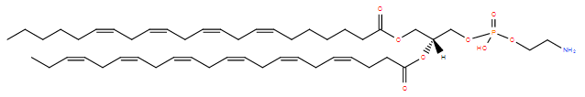

Lipid(s): LMGP01030016

Current classification: Glycerophospholipids [GP] > Glycerophosphocholines [GP01] > 1-(1Z-alkenyl),2-acylglycerophosphocholines [GP0103]

Suggested classification: Glycerophospholipids [GP] > Glycerophosphoethanolamines [GP02] > Diacylglycerophosphoethanolamines [GP0201]

Discussion: The structure consists of two fatty acyls joined to the glycerol backbone at the 1 and 2 positions.  Thus, it is inaccurate to describe it as a alkenyl containing group.  The right classification is the diacylglycero-phosphocholine.

|  |  |
| --- | --- |
| Representative lipids from current subclass: | Representative lipids from suggested subclass: |
| LMGP01030004 | LMGP02010003 |
|  |  |
| LMGP01030006 | LMGP02010004 |
|  |  |
| LMGP01030008 | LMGP02010005 |
|  |  |
| LMGP01030009 | LMGP02010008 |
|  |  |

2.12

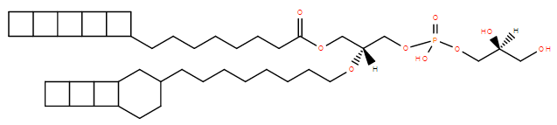

Lipid(s): LMGP04040006

Current classification: Glycerophospholipids [GP] > Glycerophosphoglycerols [GP04] > Dialkylglycerophosphoglycerols [GP0404]

Suggested classification: Glycerophospholipids [GP] > Glycerophosphoglycerols [GP04] > 1-acyl,2-alkylglycerophosphoglycerols [GP0411]

Discussion: This lipid has an ester group characteristic of lipids in the “1-acyl,2-alkylglycerophosphoglycerols” subclass.

|  |  |
| --- | --- |
| Representative lipids from current subclass: | Representative lipids from suggested subclass: |
| LMGP04040002 | LMGP04110001 |
|  |  |
| LMGP04040003 | LMGP04110002 |
|  |  |
| LMGP04040004 | LMGP04110003 |
|  |  |
| LMGP04040005 | LMGP04110004 |
|  |  |

2.13

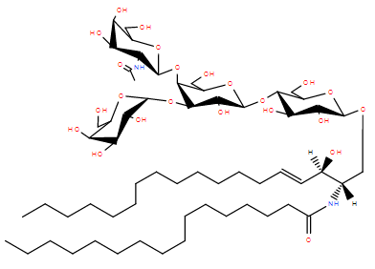

Lipid(s): LMSP0505DO01,

Current classification: Sphingolipids [SP] > Neutral glycosphingolipids [SP05] > Galβ1-4GlcNAcβ1-3Galβ1-4Glc- (Neolacto series) [SP0505]

Suggested classification: Sphingolipids [SP] > Neutral glycosphingolipids [SP05] > GalNAcβ1-4Galβ1-4Glc- (Ganglio series) [SP0503]

Discussion: The sugar chain starting from Ceramide fits the Ganglio series root exactly (GalNAc-Gal-Gal-Glc-Cer.). Discussion continued on the next page.

|  |  |
| --- | --- |
| Representative lipids from current subclass: | Representative lipids from suggested subclass: |
| LMSP0505AA01 | LMSP0503AA01 |
|  |  |
| LMSP0505AA02 | LMSP0503AN01 |
|  |  |
| LMSP0505AA03 | LMSP0503AO01 |
|  |  |
| LMSP0505AA04 | LMSP0503AP01 |
|  |  |

2.14

-Continued Discussion of Lipids similar to LMSP0505DO01-08

Lipid(s): LMSP0505DP01-LMSP0505DP08, LMSP0505DQ01-LMSP0505DQ08, LMSP0505DR01-LMSP0505DR08, LMSP0505DS01-LMSP0505DS08

(1-8 in each sub-sub section because only the Ceramide chain changes)

Current classification: Sphingolipids [SP] > Neutral glycosphingolipids [SP05] > Galβ1-4GlcNAcβ1-3Galβ1-4Glc- (Neolacto series) [SP0505]

Suggested classification: Sphingolipids [SP] > Neutral glycosphingolipids [SP05] > GalNAcβ1-4Galβ1-4Glc- (Ganglio series) [SP0503]

Discussion: The structure is branched but the structure fits one root better than the other and based on the 1997 IUPAC guidelines for naming glycolipids and the LIPID MAPS own grouping rules, the root structure determines the group.

|  |  |
| --- | --- |
| Representative lipids from current subclass: | Representative lipids from suggested subclass: |
| LMSP0505DP01 | LMSP0503 Ganglio series |
|  | Each of the sub-sub groups after DO from DP-DS are the exact same as DO sub-sub group’s structure, but with the addition of one sugar to the side chain for each new group. This allows them to be grouped as part of the Ganglio series as well. Also none of these glycolipids have the neolacto series root. |
| LMSP0505DQ01 |
|  |
| LMSP0505DR01 |
|  |
| LMSP0505DS01 |
|  |

2.15

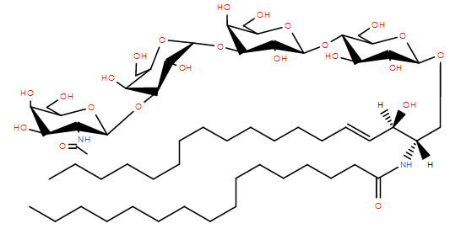

Lipid(s): LMSP0505DA01-LMSP0505DA08, LMSP0505DB01-LMSP0505DB08, LMSP0505DJ01-LMSP0505DJ08, LMSP0505DK01-LMSP0505DK08, LMSP0505DL01-LMSP0505DL08 (1-8 in each sub-sub section because only the Ceramide chain changes)

Current classification: Sphingolipids [SP] > Neutral glycosphingolipids [SP05] > Galβ1-4GlcNAcβ1-3Galβ1-4Glc- (Neolacto series) [SP0505]

Suggested classification: Sphingolipids [SP] > Neutral glycosphingolipids [SP05] > GalNAcβ1-3Galα1-3Galβ1-4Glc- (Isoglobo series) [SP0506]

Discussion: Based on the 1997 IUPAC guidelines for naming glycolipids and the sub-sub groupings of LIPID MAPS themselves, these lipids fit the glyco-root of the Isoglobo series because these lipids don’t have an N-acetyl-glucosamine in the third position from the Ceramide and have all the correct linkage for the Isoglobo series.

|  |  |
| --- | --- |
| Representative lipids from current subclass: | Representative lipids from suggested subclass: |
| LMSP0505AA01 | LMSP0506AD01 |
|  |  |
| LMSP0505 (Neolacto series) | LMSP0506 (Isoglobo series) |
| Galβ1-4GlcNAcβ1-3Galβ1-4Glc-Cer | GalNAcβ1-3Galα1-3Galβ1-4Glc-Cer |

1. **New Ontology**

3.1 Table 2 – table title???

|  |  |  |
| --- | --- | --- |
| Current Ontology | New Suggested Ontology: | Root of New Suggested Ontology |
| LMSP0505DC01-08 LMSP0505DD01-08  LMSP0505DE01-08 LMSP0505DF01-08 | LMSP0510 (gluco-globo series) [10] | GlcNAcβ1-3Galα1-3Galβ1-4Glcβ-Cer |
| LMSP0505DM01-08 LMSP0505DN01-08 | LMSP0511 (galacto-lacto series) [11] | Galα1-3Galα1-3Galβ1-4Glcβ-Cer |

The table shows the lipids that would fit more appropriately in a new subclass of lipids. The new subclass LMSP0510 (gluco-globo) is suggested for the LMSP0505DC-DF lipids because the root of these lipids is similar to the isoglobo series and contains a terminal N-acetyl glucosamine. NAME AND REASONING FOR GALACTO-LACTO… The roots of the new suggested ontologies are shown to illustrate that these lipids do not fit well with the root of the current classification, LMSP0505, Galβ1-4GlcNAcβ1-3Galβ1-4Glc-Cer.